**SELECT CLAUSE.**

**1.Display details of jobs where the minimum salary is greater than 10000.**

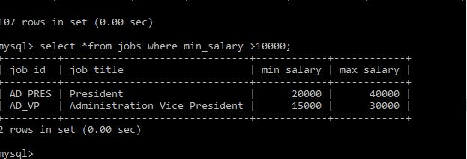

**2.Display the first name and join date of the employees who joined between 2002 and 2005.**

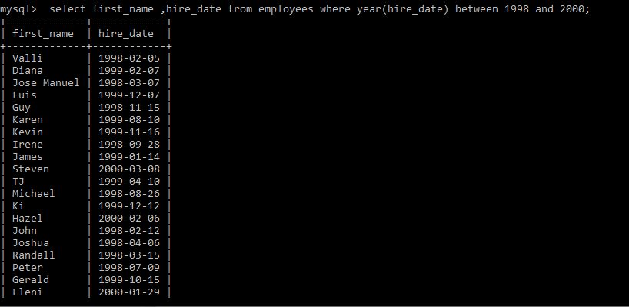

**3.Display first name and join date of the employees who is either IT Programmer or Sales** 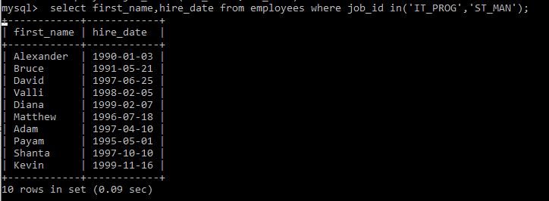

1. **Display first name, salary, commission pct, and hire date for employees with salary less than 1000.**

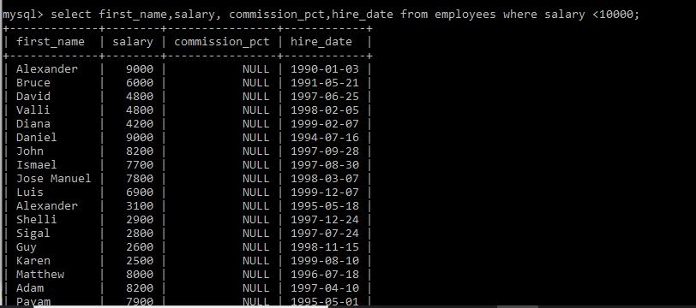

1. **Display job Title, the difference between minimum and maximum salaries for jobs with max salary in the range 10000 to 20000.**

**select job_title ,max(salary)-min(salary) difference from jobs where max(salary) between 10000 and 20000;**

**6.Display employees where the first name or last name starts with S.**

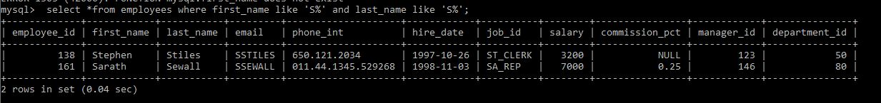

**7.Display details of jobs in the descending order of the title**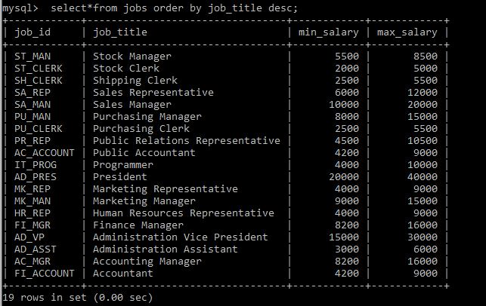

**8. Display employees who joined in the month of May.**

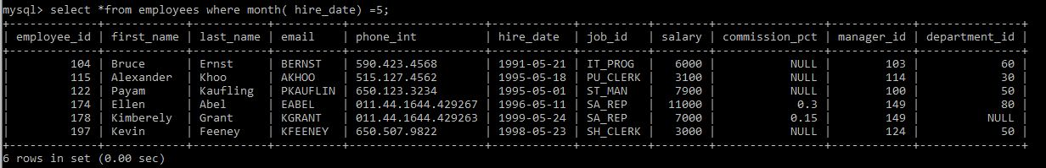

1. **Display details of the employees where commission percentage is null and salary in the range 5000 to 10000 and department is 30.**

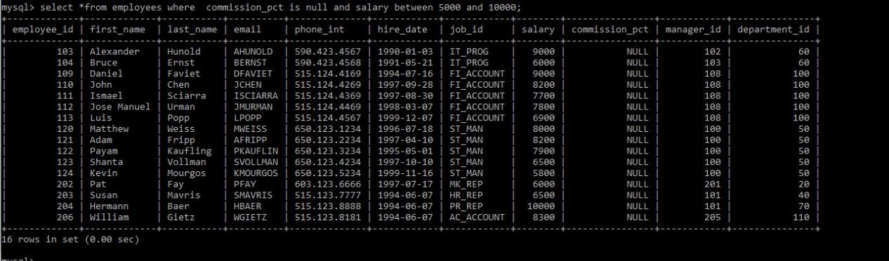

**JOIN.**

**1). Display job title, employee ID, number of days between ending date and starting date for all jobs in department 30 from job history.**

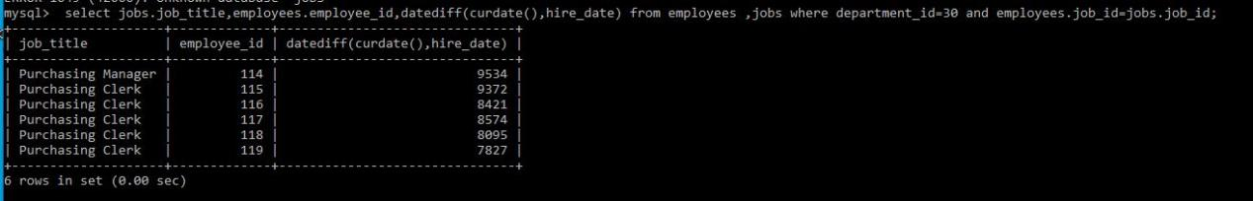

1. **Display department name and manager first name.**

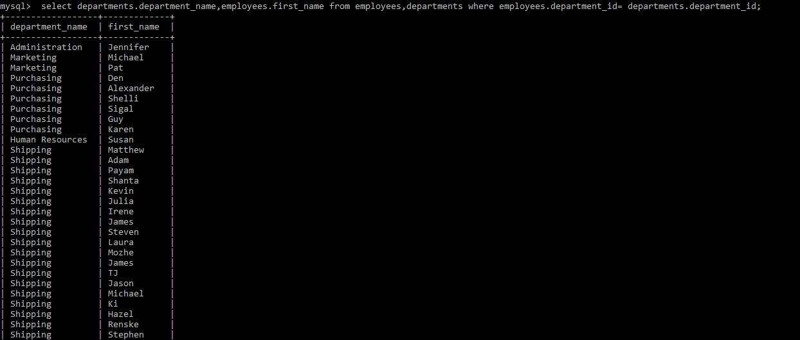

**3) Display department name, manager name, and city.**

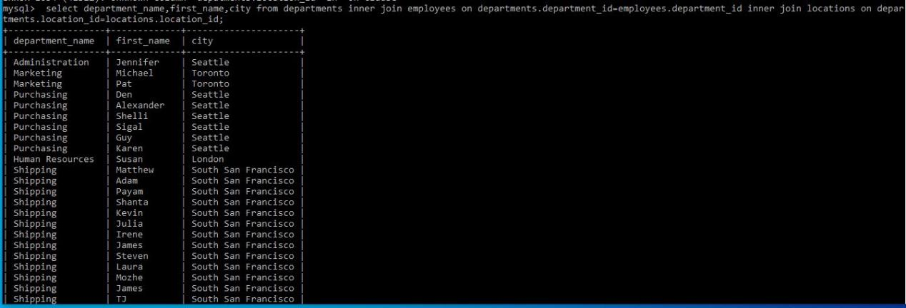

**4) Display country name, city, and department name.**

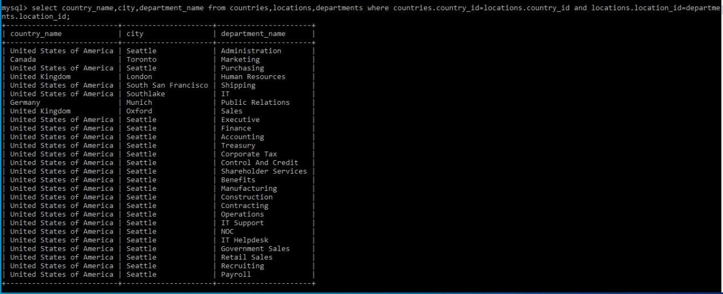

**5) Display employee name and country in which he is working.**

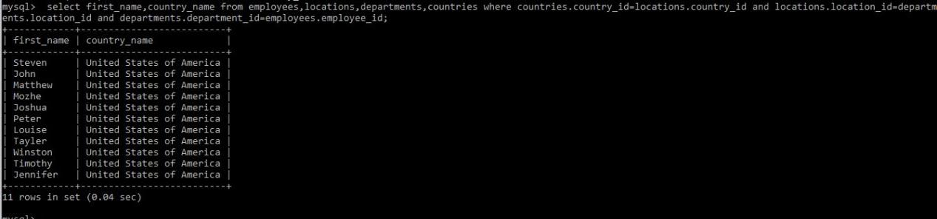

**Functions**

**1. Display employees who joined in the month of May.**

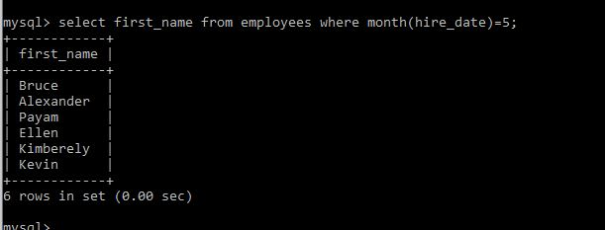

**2.Display first name, salary, and round the salary to thousands.**



**3. Display first name and date of first salary of the employees.**

**4. Display first name and experience of the employees.**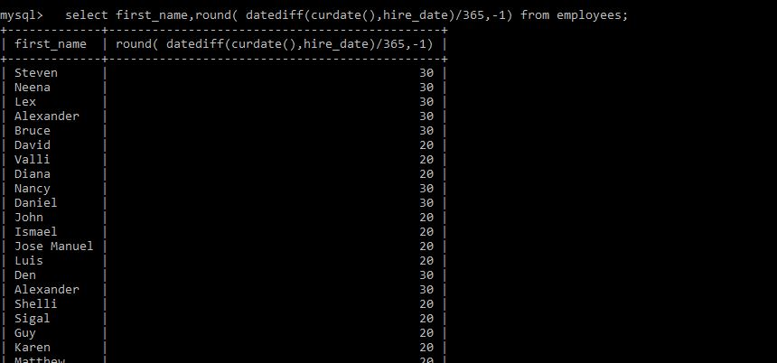

**5. Display the length of first name for employees where last name contain character ‘b’ after 3rd position.**



1. **Display first name in upper case and email address in lower case for employees where the first name and email address are same irrespective of the case.**

**function(6)**

**7. Display employees who joined in the current year.**

**function(7)**

**8. Display the number of days between system date and 1st January 1995.**



**9. Display how many employees joined in each month of the current year.**

**MySQL Aggregate function**

**1. Display employee ID and the date on which he ended his previous job.**

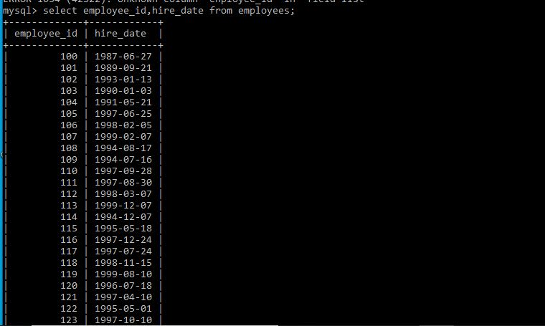

**2. Display number of employees joined after 15th of the month**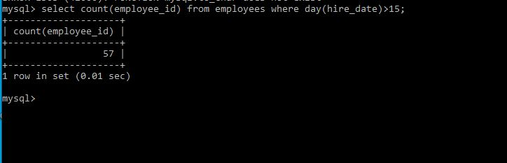

**select with Group by**

**3. Display the country ID and number of cities we have in the country.**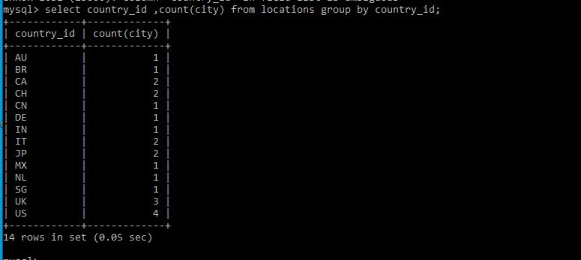

**4. Display average salary of employees in each department who have commission percentage.**

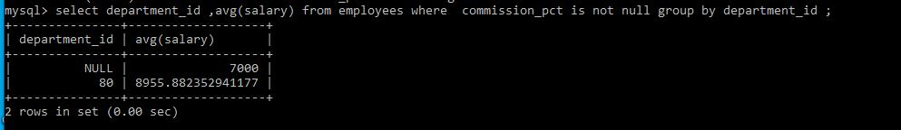

**5. Display job ID, number of employees, sum of salary of employees.**

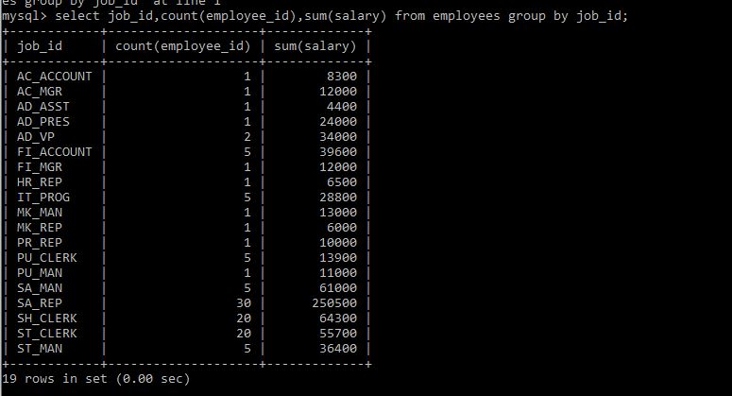

**6. Display job ID for jobs with average salary more than 10000.**

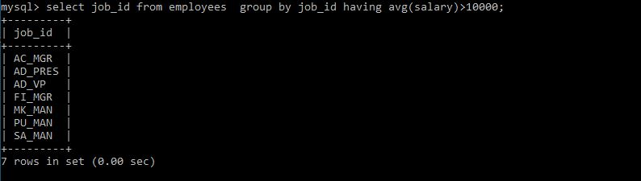

**7.Display years in which more than 10 employees joined.**

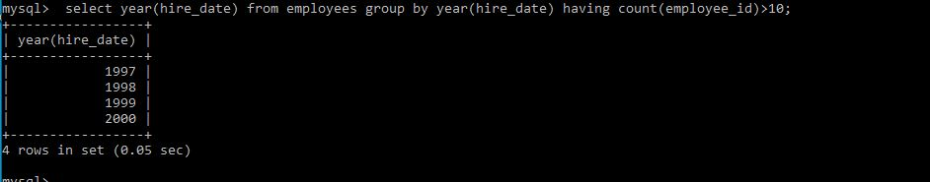

**8. Display departments in which more than five employees have commission percentage.**

**select department_id from employees where commission_pct is not null group by department_id having count (commission_pct)>5;**

**9.Display department name and number of employees in the department.**

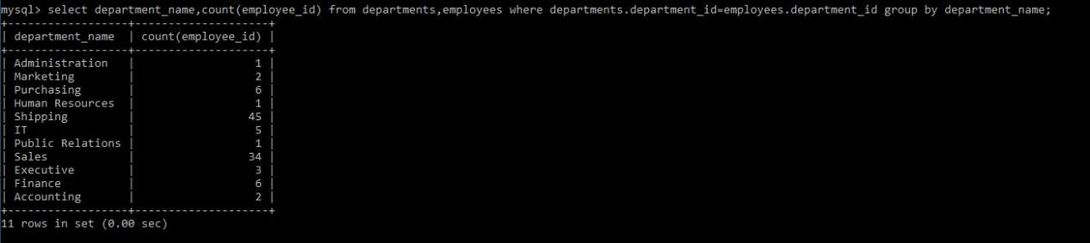

**10. Display employee ID for employees who did more than one job in the past.**

